

**TEam Kaizen reporT**

**Top Trumps MSc Group Project**



February 18, 2019

Team KAIZEN

Top Trumps MSc Group Project

|  |  |
| --- | --- |
| **GUID:** | **Name:** |
| 2146919D | Florin Danila Casian |
| 2387688L | Xiaoyu Lu |
| 2147974P | Luca Palkovits |
| 2411100P | Radu Petrescu |
| 2351028T | Maaz Bin Tariq |

Contents

Project Summary: 2

User Roles 3

User Stories 3

Planning and review reports 6

Sprints Overview 6

Planning and review report Sprint 1 7

General 7

Team Info 7

Completion and timing* 7

Project Backlog after Sprint* 8

Planning and review report Sprint 2 9

General 9

Team Info 9

Completion and timing* 10

Project Backlog after Sprint* 11

Project Burndown Chart 13

Conclusion: 13

Assumptions 13

Testing 15

Deficiencies 18

Appendix 1 – Screenshots Main Functionality & Testing 18

1.1 As a user I want to be able to choose cmd gameplay mode. 22

1.2 As a user I want to load a deck of cards. 24

1.3 As a dealer I want to be able to shuffle deck of cards. 25

1.4 As a human or AI player I want to receive fair share of cards. 26

1.5 As a human player I want to see the details of the top card. 26

1.6 As a human player I want to choose option for top card. 27

1.7 As an AI player I want to choose best option for top card. 28

1.8 As a dealer I want to choose random first player. 29

1.9 As a human player I want to see relevant game data. 30

1.10 As a human player I want to see who wins the round, the game and details of the common pile. 31

1.11 As a human or AI player I want to start the next round if I won the previous one. 35

1.12 As a dealer I want to make sure that once a player is eliminated, they do not participate in any more rounds. 38

1.13 As a human player I want to choose number of AI opponents. 39

1.14 As a user I want to receive an output of gameplay details. 40

1.15 As a user I want to store specific persistent game data at the end of the game. 41

1.16 As a user I want to have functional “Start Game” and “Show Statistics” buttons for online mode. 43

Appendix 2 – References 44

# Project Summary:

* Top Trumps is a simple card game in which decks of cards are based on a theme.
* Our team used a single deck. The deck theme involves **DOTA2** Characters.
* Each deck has a list of characteristics. Our characteristics are:
  + *Attack;*
  + *Health;*
  + *Strength;*
  + *Agility;*
  + *Intelligence;*
* The aim of the program is to allow the user to play the game in both command line and online mode versus 1 to 4 other AI players.
* **The program meets all functionality and specifications conveyed in the assignment requirements document. All user stories beside would like to have’s have been covered.** More details are presented below.

# User Roles

* **The User / Human Player**
  + This is the human player who uses the program on a laptop. The role is bi-partite involving game specific use as a player (example: playing the game per se) and general use as a user (example: viewing database statistics).
* **The AI player(s)**
  + This is the AI player that must make smart decisions while playing the game with the human player. The role only involves gameplay, there is no involvement in general use.
* **The Robot / Dealer**
  + The robot is simply an imaginary dealer that is responsible for anything involving card automations or game logic within the program.

# User Stories[1]

| **#** | **Story** | **Conversations** | **Priority[2]** | **E_time[3]** | **A_time** |
| --- | --- | --- | --- | --- | --- |
| 1 | As a user I want to be able to choose command line (cmd) gameplay mode. | Done initially via cmd flag -c. Command line processing is already present in the package. | MUST | 0.2 | 0.1 |
| 2 | As a user I want to load a deck of cards. | We assume for the main program there is only one deck of cards. There is no need for file chooser. The deck .txt file resides in the home folder of the program. | MUST | 1 | 2 |
| 3 | As a dealer I want to be able to shuffle deck of cards. | This can be done using Collections shuffle. | MUST | 0.2 | 0.1 |
| 4 | As a human or AI player I want to receive fair share of cards. | There are 40 cards. Special rule must be implemented for 3 players (40%3<>0). | MUST | 0.2 | 0.1 |
| 5 | As a human player I want to see the details of the top card. | Iterate attributes of card in System.out. Easy to implement. | MUST | 0.2 | 0.1 |
| 6 | As a human player I want to choose card attribute. | Choose an attribute by number input through System.in. | MUST | 0.2 | 0.1 |
| 7 | As an AI player I want to choose best option for top card. | From an array list of attributes choose max. Could implement hash set, maybe. | MUST | 0.2 | 0.1 |
| 8 | As a dealer I want to choose random first player. | Can use random integer from 0 to 4 or use Collections.shuffle. | MUST | 0.2 | 0.1 |
| 9 | As a human player I want to see relevant game data. | Printed in System.out. The data should involve a toString() method involving explanatory text as well. Relevant game data includes: round number, active player, card chosen, card attributes, chosen card and the human player’s remaining card count. | MUST | 5 | 6 |
| 10 | As a dealer I want to determine who wins each round. | Core game logic can be implemented in the controller. | MUST | 1 | 1 |
| 11 | As a dealer I want to determine who wins the game. | There should be a method that keeps checking if the game is terminated via a loop determined by a Boolean value. | MUST | 0.2 | 0.1 |
| 12 | As a dealer I want to keep track of the common pile. | Game logic should keep track of common pile whenever a round ends in a draw. | MUST | 0.2 | 0.1 |
| 13 | As a human player I want to see who wins the round, the game and details of the common pile. | Can be implemented via the view in cmd mode. After each action and at the end of the game System.out prints the relevant outcomes. | MUST | 0.2 | 0.1 |
| 14 | As a human or AI player I want to start the next round if I won the previous one. | Use a if(winning_player==true) construct perhaps. | MUST | 0.2 | 0.1 |
| 15 | As a human or AI player I want to receive or lose cards in/from my pack, if I win or lose, respectively. | Add() or remove() methods can be used. Array can be used to store the cards that are in play each round. These are subsequently appended to the winner’s pack. | MUST | 0.2 | 0.1 |
| 16 | As a human or AI player I want to append the cards that I won to the back of my pack. | Array list could be used with an add() method. | MUST | 0.2 | 0.1 |
| 17 | As a dealer I want to make sure that once a player is eliminated, they do not participate in any more rounds. | Each player has a Boolean variable initiated with true allowing them to participate in rounds. When eliminated, variable should change to false. | MUST | 0.2 | 0.1 |
| 18 | As a human player I want to choose number of AI opponents. | System.in with an integer input from 1 to 4. | MUST | 0.2 | 0.1 |
| 19 | As a user I want to receive an output of gameplay details. | Test log. File Writer is used to generate .txt file with output similar to the cmd view class. | SHOULD | 1 | 1.5 |
| 20 | As a user I want to store specific persistent game data at the end of the game. | Postgresql jar used – a Connection class based on the jar can be used to manage all database connections and transactions. | SHOULD | 2 | 1.5 |
| 21 | As a user I want to retrieve persistent data on past games. | Connection class is used. Specific cmd flag is used upon program startup. Select and to string can be used to retrieve data in console or web view. | SHOULD | 2 | 1.5 |
| 22 | As a user I want to choose between cmd and online mode. | Done using cmd flags as per initial project template (Moodle). | COULD | 0.5 | 0.2 |
| 23 | As a user I want to have functional “Start Game” and “Show Statistics” buttons for online mode. | 2 clickable buttons in browser. | COULD | 0.5 | 0.3 |
| 24 | As a user I want to have a button framework for choosing number of AI players online. | Could be either clickable buttons or combo-box. | COULD | 0.5 | 1 |
| 25 | As a user I want to see card graphics for each player. | Card static images used. Card could be a picture or an iteration of attributes combined with a picture. | COULD | 3 | 1 |
| 26 | As a user I want to have buttons for choosing attributes online. | Could be either clickable buttons or combo-box. | COULD | 3 | 1 |
| 27 | As a user I want to have a ‘Next Round’ button online. | Single button. | COULD | 0.5 | .5 |
| 28 | As a user I want to see text representation for round and game outcomes, as well as database statistics. | Section of screen displaying text (simple html implementation). | COULD | 3 | 11 |
| *29* | *As a user I would like to choose a relevant deck from command line or online mode.* | *Could have more decks, graphical assets and choice option in cmd (Scanner/FileChooser) or online (ComboBox).* | *WLTH* | *2* | *0\** |
| *30* | *As a user I would like to choose between AI difficulties.* | *Easy is for random attribute choice. Medium is for best attribute choice. Hard is for smart distribution-knowledge attribute choice (example: AI chooses most probable statistical win based on overall attribute distribution).* | *WLTH* | *2* | *0\** |

*Not implemented in final product.

# Planning and review reports

## Sprints Overview

|  |  |  |  |
| --- | --- | --- | --- |
| **Sprint #** | **Week #** | **Timeframe** | **Ideal days per week\*** |
| 1 | 1 | 7 – 13 Jan | 5 |
| 2 | 14 – 20 Jan | 5 |
| 3 | 21 – 27 Jan | 5 |
| 2 | 4 | 28 – 3 Feb | 5 |
| 5 | 4 – 10 Feb | 5 |
| 6 | 11 – 17 Feb | 5 |

* One story point corresponds to an ideal day.

## Planning and review report Sprint 1

### General

|  |  |
| --- | --- |
| **Sprint Dates:** | 7 January 2019 – 27 January 2019 |
| **Sprint ideal days/story point capacity:** | 15 points |
| **Planned velocity:** | 15 points |
| **Actual velocity:** | 15 points |

### Team Info

|  |  |  |
| --- | --- | --- |
| **Role\*** | **Name** | **Effort Proportion** |
| Java Developer and Tester | Casian | 20% |
| Java and JavaScript Developer | Xiaoyu | 20% |
| Java Developer and Tester | Luca | 20% |
| Integration Developer and Database Administrator ** | Radu | 20% |
| Java and JavaScript Developer | Maaz | 20% |

*Documentation and research were done as required by all team members.

**Planning Manager and Scrum Master.

### Completion and timing*

|  |  |  |  |
| --- | --- | --- | --- |
| **User Story #** | **Complete** | **Story points (planned)** | **Story points (actual)\*** |
| 1 | Yes | 0.2 | 0.1 |
| 2 | Yes | 1 | 2 |
| 3 | Yes | 0.2 | 0.1 |
| 4 | Yes | 0.2 | 0.1 |
| 5 | Yes | 0.2 | 0.1 |
| 6 | Yes | 0.2 | 0.1 |
| 7 | Yes | 0.2 | 0.1 |
| 8 | Yes | 0.2 | 0.1 |
| 9 | Yes | 5 | 6 |
| 10 | Yes | 1 | 1 |
| 11 | Yes | 0.2 | 0.1 |
| 12 | Yes | 0.2 | 0.1 |
| 13 | Yes | 0.2 | 0.1 |
| 14 | Yes | 0.2 | 0.1 |
| 15 | Yes | 0.2 | 0.1 |
| 16 | Yes | 0.2 | 0.1 |
| 17 | Yes | 0.2 | 0.1 |
| 18 | Yes | 0.2 | 0.1 |
| 19 | Yes | 1 | 1.5 |
| 20 | Yes | 2 | 1.5 |
| 21 | Yes | 2 | 1.5 |

*Working on a user story involves all stages: research, development, testing and documentation. At the end of each working day each member of the team was asked how much they contributed and an estimate was made.

### Project Backlog after Sprint*

| **#** | **Type** | **Status** | **Estimate** | **Spent** |
| --- | --- | --- | --- | --- |
| 1 | User Story | Done | 0.2 | 0.1 |
| 2 | User Story | Done | 1 | 2 |
| 3 | User Story | Done | 0.2 | 0.1 |
| 4 | User Story | Done | 0.2 | 0.1 |
| 5 | User Story | Done | 0.2 | 0.1 |
| 6 | User Story | Done | 0.2 | 0.1 |
| 7 | User Story | Done | 0.2 | 0.1 |
| 8 | User Story | Done | 0.2 | 0.1 |
| 9 | User Story | Done | 5 | 6 |
| 10 | User Story | Done | 1 | 1 |
| 11 | User Story | Done | 0.2 | 0.1 |
| 12 | User Story | Done | 0.2 | 0.1 |
| 13 | User Story | Done | 0.2 | 0.1 |
| 14 | User Story | Done | 0.2 | 0.1 |
| 15 | User Story | Done | 0.2 | 0.1 |
| 16 | User Story | Done | 0.2 | 0.1 |
| 17 | User Story | Done | 0.2 | 0.1 |
| 18 | User Story | Done | 0.2 | 0.1 |
| 19 | User Story | Done | 1 | 1.5 |
| 20 | User Story | Done | 2 | 1.5 |
| 21 | User Story | Done | 2 | 1.5 |
| 22 | User Story | In Progress | 0.5 | 0 |
| 23 | User Story | In Progress | 0.5 | 0 |
| 24 | User Story | In Progress | 0.5 | 0 |
| 25 | User Story | In Progress | 3 | 0 |
| 26 | User Story | In Progress | 3 | 0 |
| 27 | User Story | In Progress | 0.5 | 0 |
| 28 | User Story | In Progress | 3 | 0 |
| 29 | User Story | In Progress | 2 | 0 |
| 30 | User Story | In Progress | 2 | 0 |

* No new items have been added as a result of the sprint. All existing items remain on backlog.

## Planning and review report Sprint 2

### General

|  |  |
| --- | --- |
| **Sprint Dates:** | 28 January 2019 – 17 February 2019 |
| **Sprint ideal days/story point capacity:** | 15 points |
| **Planned velocity:** | 15 points |
| **Actual velocity:** | 11 points |

### Team Info

|  |  |  |
| --- | --- | --- |
| **Role\*** | **Name** | **Effort Proportion** |
| Java Developer and Tester | Casian | 20% |
| Java and JavaScript Developer | Xiaoyu | 20% |
| Java Developer and Tester | Luca | 20% |
| Integration Developer and Database Administrator ** | Radu | 20% |
| Java and JavaScript Developer | Maaz | 20% |

*Documentation and research were done as required by all team members.

**Planning Manager and Scrum Master.

### Completion and timing*

|  |  |  |  |
| --- | --- | --- | --- |
| **User Story #** | **Complete** | **Story points (planned)** | **Story points (actual)\*** |
| 22 | Yes | 0.5 | 0.2 |
| 23 | Yes | 0.5 | 0.3 |
| 24 | Yes | 0.5 | 1 |
| 25 | Yes | 3 | 1 |
| 26 | Yes | 3 | 1 |
| 27 | Yes | 0.5 | .5 |
| 28 | Yes | 3 | 11 |
| 29 | No (not implemented) | 2 | 0 |
| 30 | No (not implemented) | 2 | 0 |

*Working on a user story involves all stages: research, development, testing and documentation. At the end of each working day each member of the team was asked how much they contributed and an estimate was made.

### Project Backlog after Sprint*

| **#** | **Type** | **Status** | **Estimate** | **Spent** |
| --- | --- | --- | --- | --- |
| 1 | User Story | Done | 0.2 | 0.1 |
| 2 | User Story | Done | 1 | 2 |
| 3 | User Story | Done | 0.2 | 0.1 |
| 4 | User Story | Done | 0.2 | 0.1 |
| 5 | User Story | Done | 0.2 | 0.1 |
| 6 | User Story | Done | 0.2 | 0.1 |
| 7 | User Story | Done | 0.2 | 0.1 |
| 8 | User Story | Done | 0.2 | 0.1 |
| 9 | User Story | Done | 5 | 6 |
| 10 | User Story | Done | 1 | 1 |
| 11 | User Story | Done | 0.2 | 0.1 |
| 12 | User Story | Done | 0.2 | 0.1 |
| 13 | User Story | Done | 0.2 | 0.1 |
| 14 | User Story | Done | 0.2 | 0.1 |
| 15 | User Story | Done | 0.2 | 0.1 |
| 16 | User Story | Done | 0.2 | 0.1 |
| 17 | User Story | Done | 0.2 | 0.1 |
| 18 | User Story | Done | 0.2 | 0.1 |
| 19 | User Story | Done | 1 | 1.5 |
| 20 | User Story | Done | 2 | 1.5 |
| 21 | User Story | Done | 2 | 1.5 |
| 22 | User Story | Done | 0.5 | 0.2 |
| 23 | User Story | Done | 0.5 | 0.3 |
| 24 | User Story | Done | 0.5 | 1 |
| 25 | User Story | Done | 3 | 1 |
| 26 | User Story | Done | 3 | 1 |
| 27 | User Story | Done | 0.5 | .5 |
| 28 | User Story | Done | 3 | 11 |
| *29* | *User Story* | *Removed* | *2* | *0* |
| *30* | *User Story* | *Removed* | *2* | *0* |

* No new items have been added as a result of the sprint. *The highlighted items have been removed from the scope of the project (story #s 29 and 30).*

# Project Burndown Chart

## Conclusion:

All user stories with priorities above “Would Like To Have”(WLTH) have been completed. The 4 point discrepancy at the end of the project (workday 30) represent user stories 29 and 30 – these are the WLTHs that have been removed from the scope of the project.

# Assumptions

* There should be one human player and up to 4 computer players (AIs).
* Assume game has at least 2 players. Human player cannot therefore play alone as game logic would not make sense.
* If a deck does not divide equally between the players, then some players may have less cards. For example, if there are 3 players and 40 cards, then two players receive 13 cards and one player receives 14.
* A deck has only 5 criteria and the criteria are always positive integers between 1 and 50 (inclusive).
* A higher number is always better for any given characteristic.
* There are 40 cards in a DotaDeck.txt file.
* The first player should be selected at random.
* A draw won't continue until the point where there are only cards in the communal pile – there is no need to deal with this from a programming perspective.
* There is only one operational deck of cards present in the project folder.
* Assume “You” in cmd refers to human player.
* Assume cards go to the back of the winning deck.
* Collections.shuffle() is a good enough shuffle for the purpose of the cards and can therefore be implemented.
* Assume any user (human or AI) can only see and interact with the top card of the deck. Players cannot therefore choose between cards.
* Assume AI is smart and chooses the best numerical option.
* Assume fast forwarding the GUI (cmd or otherwise) is appropriate once human player has lost and has no more choices to make. This avoids the potential tedious nature of the game.
* Assume the round winner starts next round.
* In the event of a round draw, all cards go into the common pile. As soon as the following round ends in a win, the winning player gets the cards from the current round as well as any from the common pile (also referred to as the communal pile).
* Assume cards are always appended to the back of the pack.
* An eliminated player (human or AI) cannot participate in further rounds in the current game.
* Assume there is no multiplayer – multiple players in the game.
* Assume between 1 and 4 AI players.
* Assume no JUnit is needed for documentation.
* Assume card names are unique.
* Assume card pictures are appropriate representations for the online GUI.
* Assume the player does not refresh or close the web page during online mode. Only buttons are used. Failure to do so may result in unpredictable behaviour.
* Assume the following general outline/wireframe is sufficient from a user experience perspective concerning the online game mode:

|  |  |  |  |
| --- | --- | --- | --- |
| URL: | http://...topTrumps/game... | | |
| **Header**  **Game logic text 1** | | | |
| **Game buttons** | **Card 1** | **Card 2** | **Card 3** |
| **Card 4** | **Card 5** | **Game logic text 2** |

* Assume fading effect is sufficient to highlight a card in the online mode GUI.

# Testing

Testing has involved manual testing, inspecting the GameLog.txt (-t flag) file versus actual game running and JUnit testing (relevant classes are TTModelTest and TTControllerTest in the test folder). Testing was done extensively while coding as well as after each version of the software artifact was produced. The team found it helpful to structure the tests based on the user stories involved.

The following is a summary of all the tests undertaken for the project.

| **Story** | **Test[4]** | **Appendix** |
| --- | --- | --- |
| As a user I want to be able to choose cmd gameplay mode. | Manual test passed - Printscreen of actual functionality. | **1.1** |
| As a user I want to load a deck of cards. | Junit test passed - Class: TTModelTest – method: testCardsRead(). Since we assume there is only one deck, no further manual testing with dummy .txt files is needed. | **1.2** |
| As a dealer I want to be able to shuffle deck of cards. | Manual testing passed – print screen from test mode to check if the deck is shuffled. | **1.3** |
| As a human or AI player I want to receive fair share of cards. | Junit test passed - Class: TTModelTest – method: testCardsDistributed(). The method checks if the cards are distributed equally among players and if the rule concerning 3 players applies. | **1.4** |
| As a human player I want to see the details of the top card. | Manual test passed – Printscreen of top card in cmd and online mode. | **1.5** |
| As a human player I want to choose option for top card. | Manual test passed – Printscreen of top card attribute chosen in cmd and online mode. | **1.6** |
| As an AI player I want to choose best option for top card. | Junit test passed - Class: TTControllerTest – method: playRoundTest(). The test checks if the AI player chooses the highest attribute for the card. This has also been tested in cmd and online mode in repeated practices. | **1.7** |
| As a dealer I want to choose random first player. | Manual test passed – Printscreen of first player chosen randomly in both cmd and online mode. In the print screen in the Appendix below, AIPlayer4 is randomly chosen as the first player. | **1.8** |
| As a human player I want to see relevant game data. | Manual test passed – all relevant game data is displayed as per requirements in both cmd and online mode. Repeated manual tests have been made with a checklist of the functionality before the tester. The checklist has been repeatedly iterated over. | **1.9** |
| As a dealer I want to determine who wins each round. | Junit test passed - Class: TTControllerTest – method: playRoundTest(). This involves general round functionality. Manual testing has also been performed for cmd and online mode. | **1.7** |
| As a dealer I want to determine who wins the game. | Junit test passed - Class: TTControllerTest – method: playRoundTest(). This involves general game functionality. Manual testing has also been performed for cmd and online mode. | **1.7** |
| As a dealer I want to keep track of the common pile. | Junit test passed - Class: TTControllerTest – method: playRoundTest().This involves general game functionality. Manual testing has also been performed for cmd and online mode. | **1.7** |
| As a human player I want to see who wins the round, the game and details of the common pile. | Manual test passed – Print screens have been provided of the functionality for the round, game and draw situation for both cmd and online modes. | **1.10** |
| As a human or AI player I want to start the next round if I won the previous one. | Manual test passed - Printscreen in cmd and online mode presented in appendix. | **1.11** |
| As a human or AI player I want to receive or lose cards in/from my pack, if I win or lose, respectively. | Manual test passed - Printscreen in cmd and online mode presented in appendix. | **1.11** |
| As a human or AI player I want to append the cards that I won to the back of my pack. | Junit test passed - Class: TTControllerTest – method: playRoundTest(). This involves general round functionality. Manual testing has also been performed for cmd and online mode. | **1.7** |
| As a dealer I want to make sure that once a player is eliminated, they do not participate in any more rounds. | Manual testing passed – Printscreens provided for both cmd and online mode. | **1.12** |
| As a human player I want to choose number of AI opponents. | Junit test passed - Class: TTModelTest – method: testNumberOfAIsChoice(). Simply checks if the number of AI’s has been correctly chosen. This has also been tested manually for both cmd and online mode. | **1.13** |
| As a user I want to receive an output of gameplay details. | Manual testing passed – printscreen of test mode file provided. This has been checked against cmd. | **1.14** |
| As a user I want to store specific persistent game data at the end of the game. | Manual testing passed. Database select has been performed after game has been played on university Yacata server. | **1.15** |
| As a user I want to retrieve persistent data on past games. | Manual testing passed. Beside the sql presented under appendix 1.15, printscreens of retrieved persistent data have been obtained in cmd and online mode. (duplicates in printscreens are due to some Yacata testing – can be ignored) | **1.16** |
| As a user I want to choose between cmd and online mode. | This has been manually checked via -c and -o flags as well as in most print screens above. | **n/a** |
| As a user I want to have functional “Start Game” and “Show Statistics” buttons for online mode. | Manual testing passed – printscreens under appendix 1.16. | **1.16** |
| As a user I want to have a button framework for choosing number of AI players online. | Manual testing passed – printscreens under appendix 1.13. | **1.13** |
| As a user I want to see card graphics for each player. | Manual testing passed – all online mode printscreens contain card graphics. | **1.13** |
| As a user I want to have buttons for choosing attributes online. | Manual testing passed – buttons present, printscreens provided. | **1.11** |
| As a user I want to have next round button online. | Manual testing passed – buttons present, printscreens provided. | **1.11** |
| As a user I want to see text representation for round and game outcomes, as well as database statistics. | Manual testing passed – all details under specifications are present. Printscreens have been provided. | **1.10** |

# Deficiencies

* No missing functionality has been identified. The program works as expected.
* There is no incorrect behaviour.
* The following potential areas of improvement have been identified:
  + Accessing the /game page in online mode without first going to the topTrumps/ page does not work as no cards are initialized and therefore displayed. This is expected behaviour, but perhaps a default session could solve this.
  + Using an incognito tab in Chrome is important in case preset settings are used from an earlier version of the code. This has happened numerous time when using Chrome without incognito mode.
  + It is very statistically improbable to get a draw due to a the structure of the deck. This is in expected – any attributes may be modified.
  + Refreshing goes back one round on the /game page in online mode – we assume user does not refresh. Perhaps some cookies could be used to improve this and save session/instance details.

# Appendix 1 – Screenshots Main Functionality & Testing

The following is a representation of the normal functionality of the game:

1. Command line mode – get statistics view:

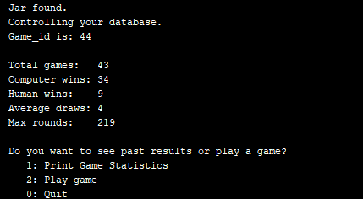

1. Command line mode – play game with 4 AI players, as chosen by human player:

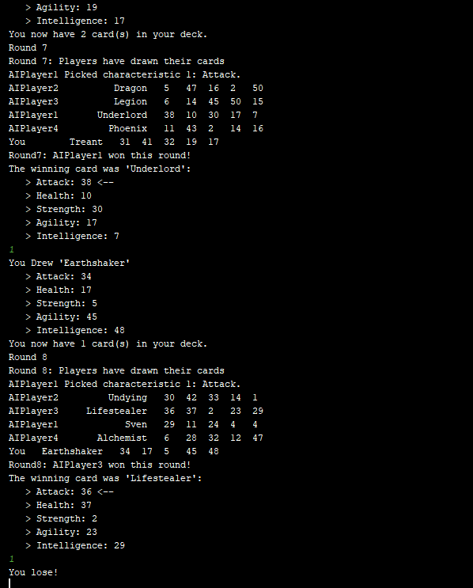

1. Command line mode – test log (actual .txt):

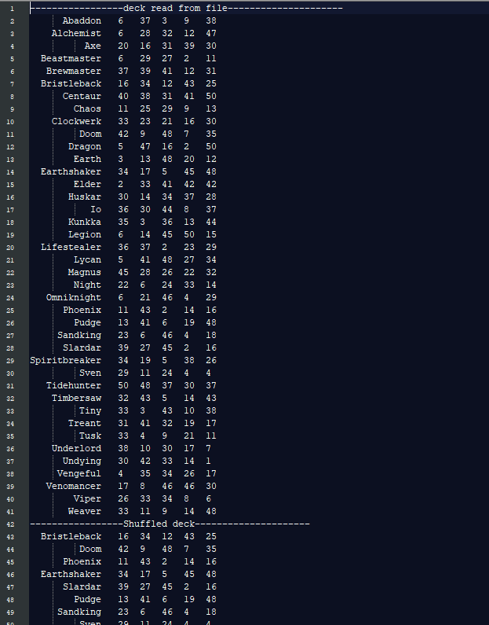

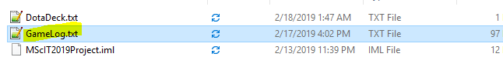

1. Online mode – get statistics view:

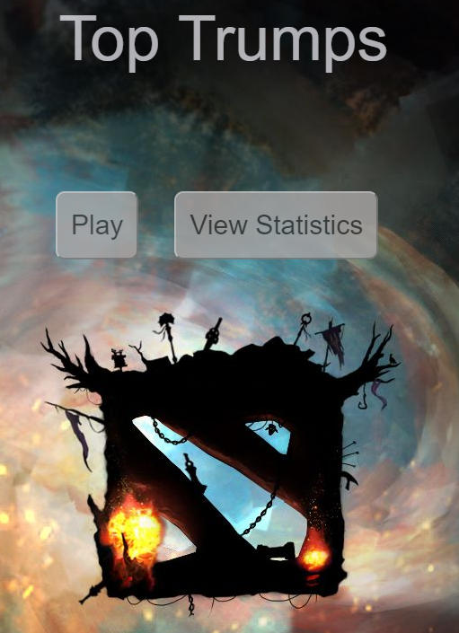

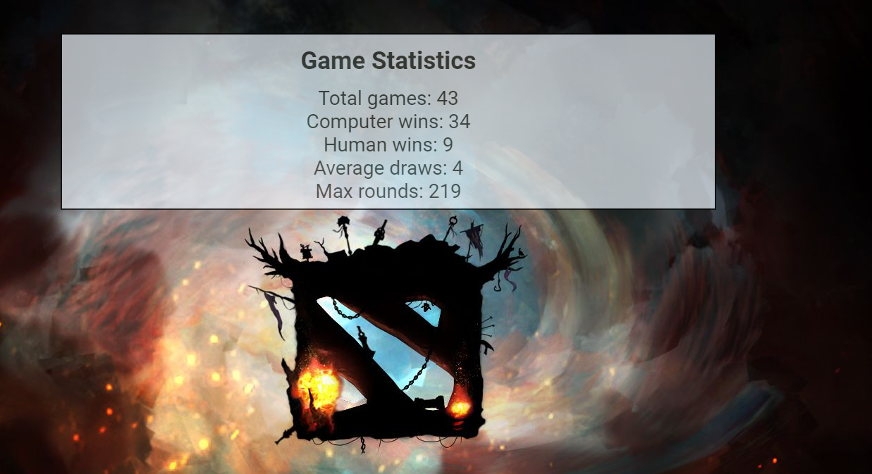

1. Online mode – play game:

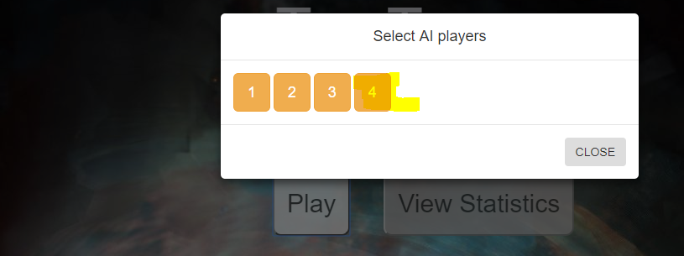

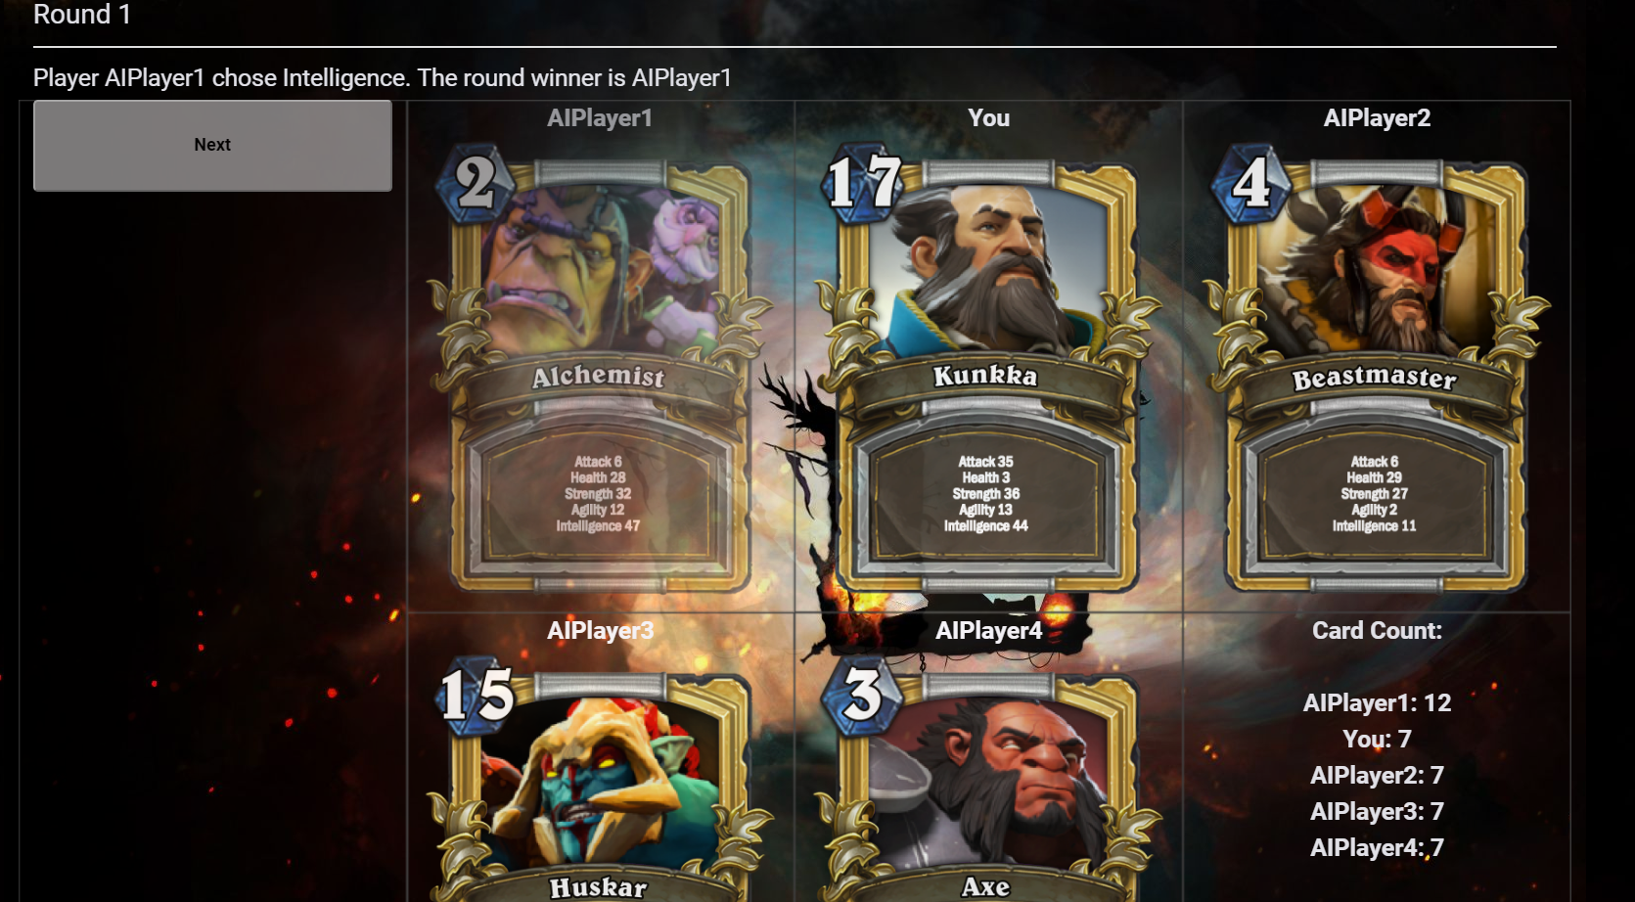

## 1.1 As a user I want to be able to choose cmd gameplay mode.

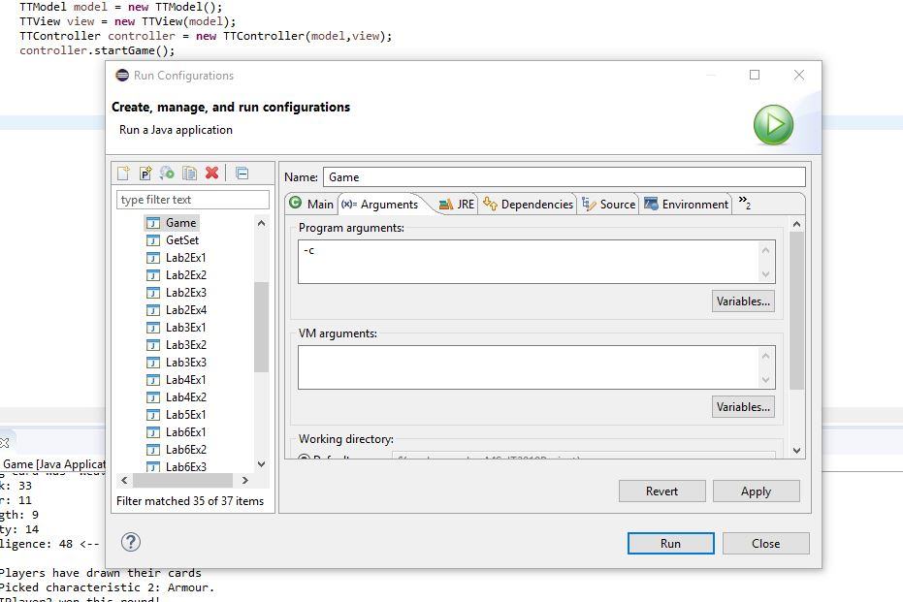

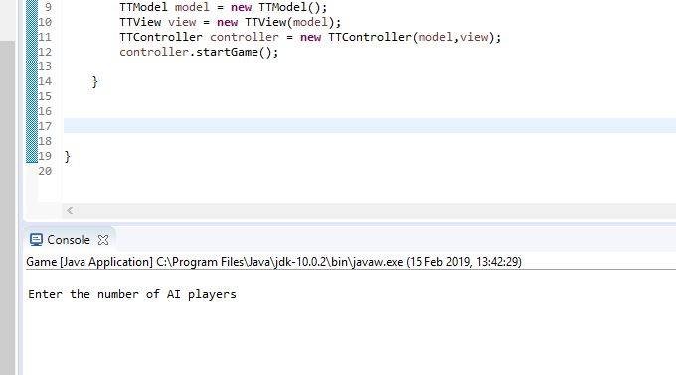

## 1.2 As a user I want to load a deck of cards.

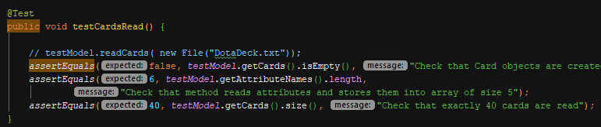

## 1.3 As a dealer I want to be able to shuffle deck of cards.

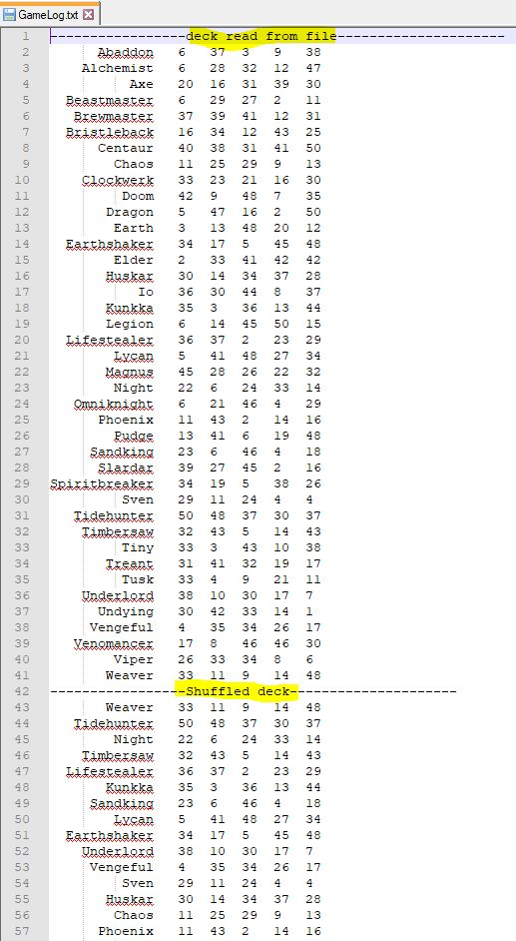

## 1.4 As a human or AI player I want to receive fair share of cards.

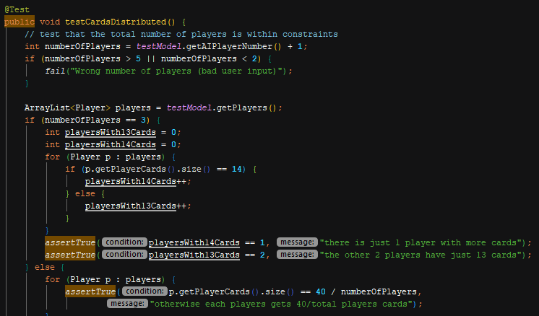

## 1.5 As a human player I want to see the details of the top card.

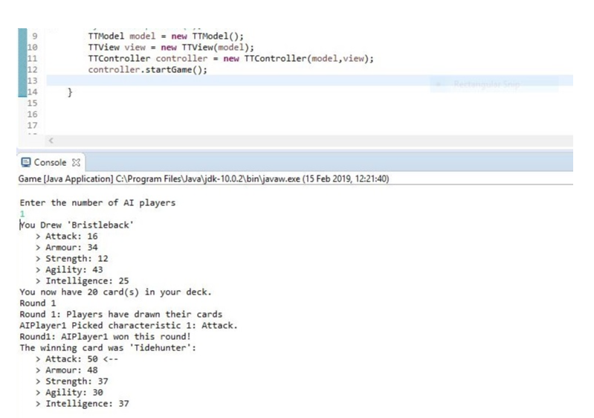

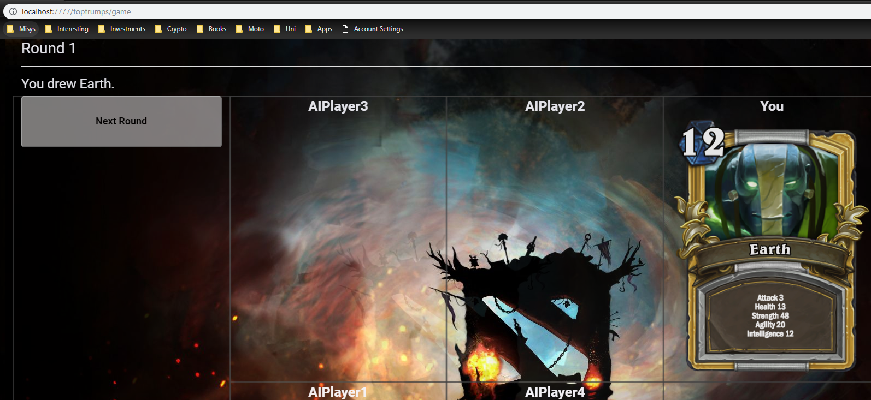

## 1.6 As a human player I want to choose option for top card.

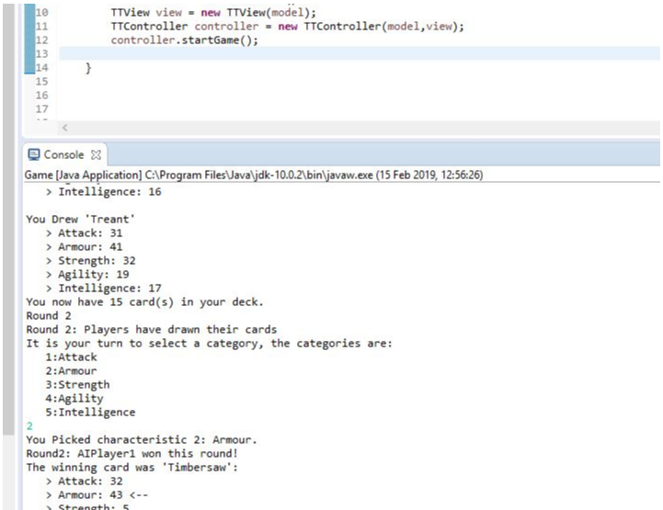

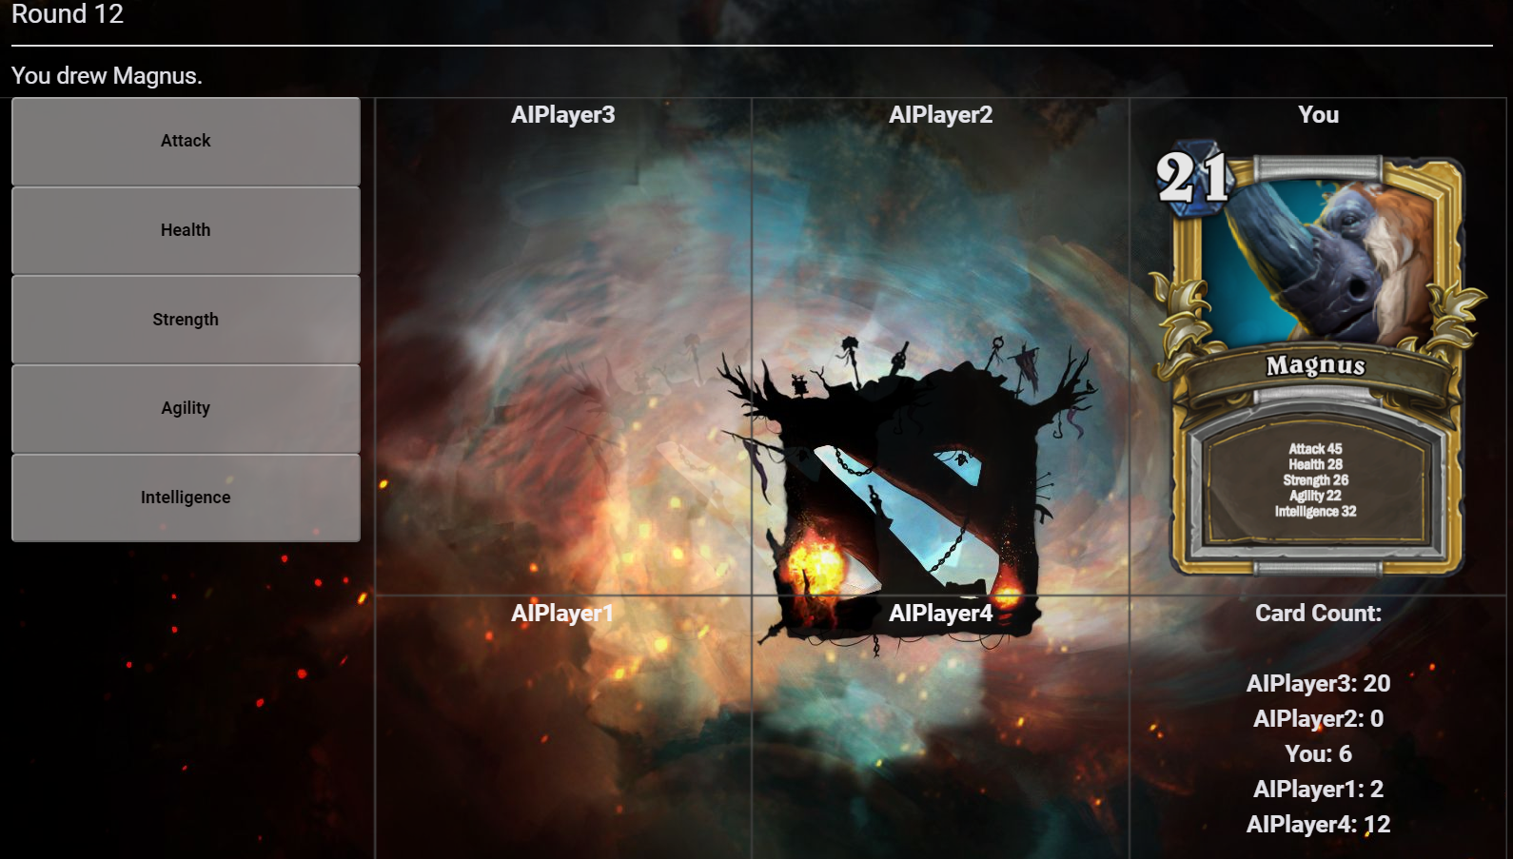

## 1.7 As an AI player I want to choose best option for top card.

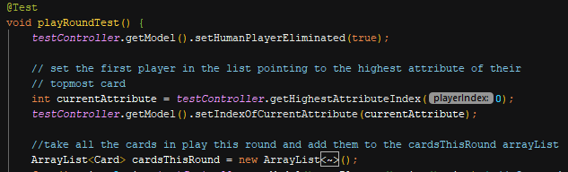

## 1.8 As a dealer I want to choose random first player.

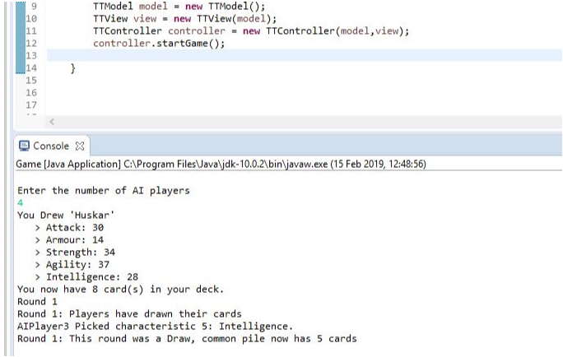

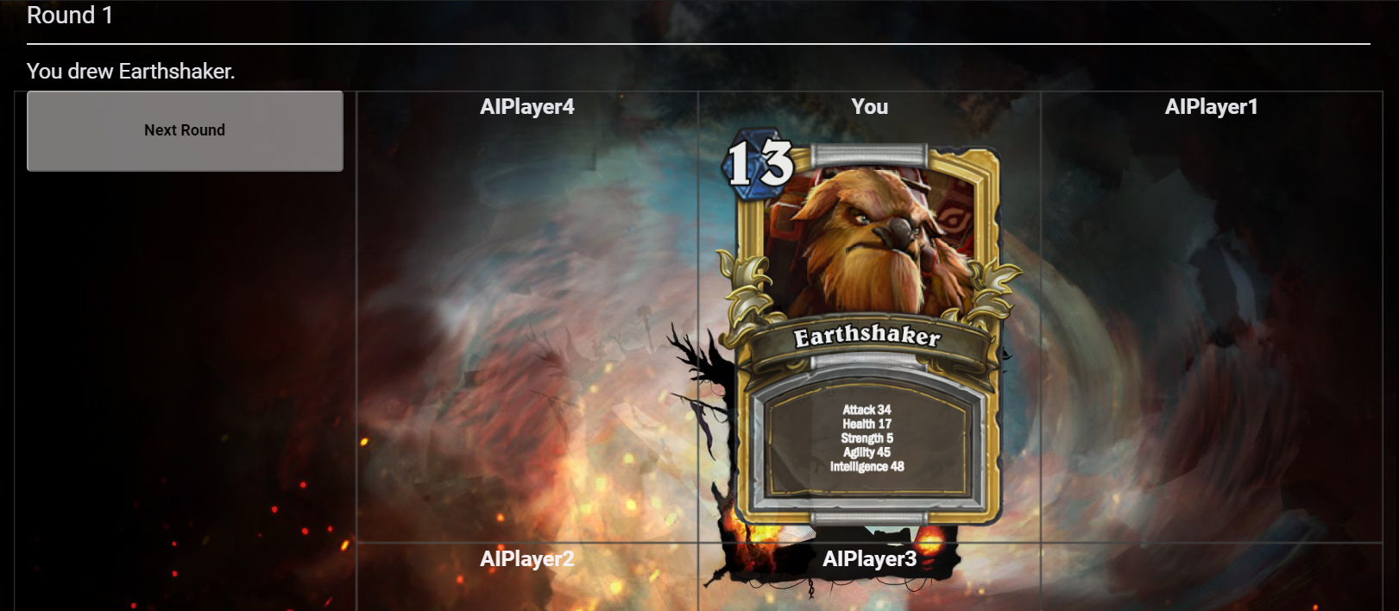

## 1.9 As a human player I want to see relevant game data.

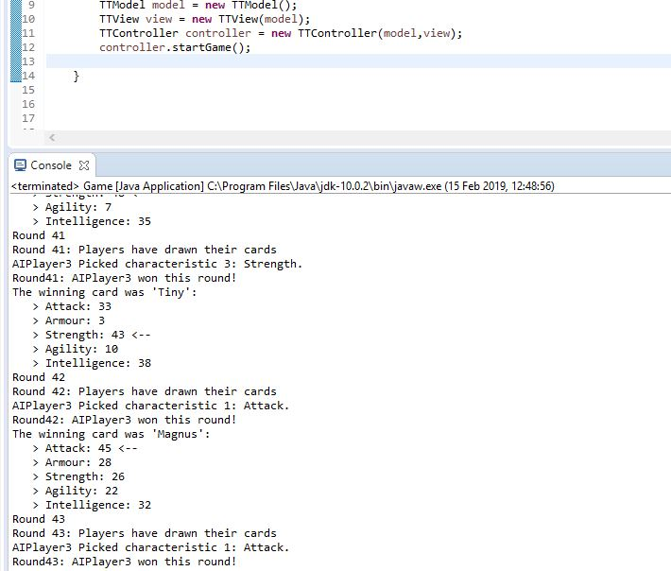

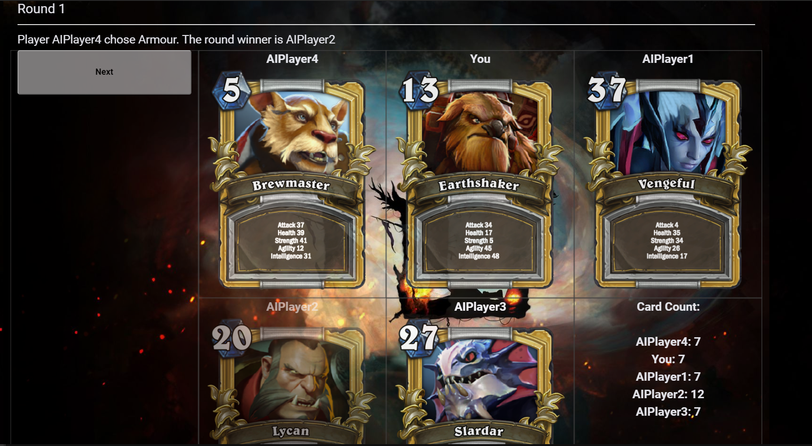

## 1.10 As a human player I want to see who wins the round, the game and details of the common pile.

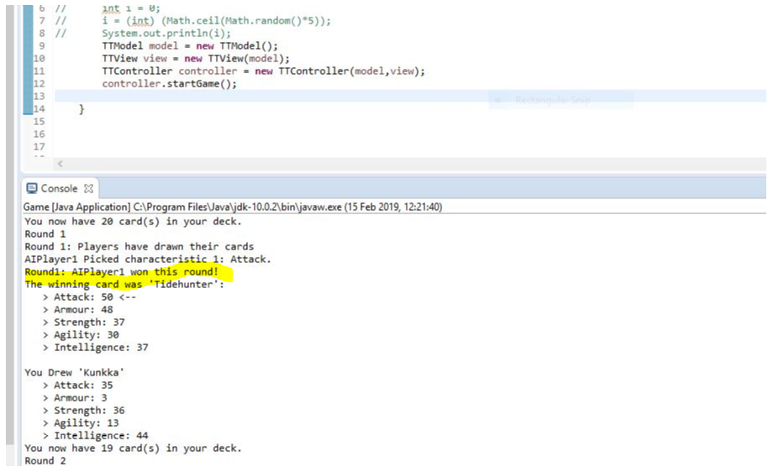

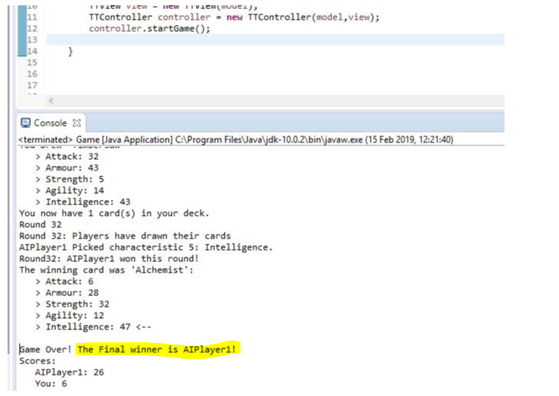

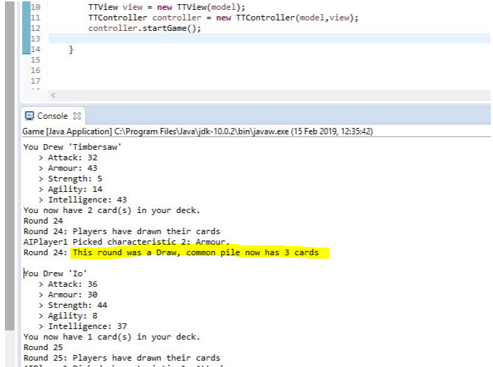

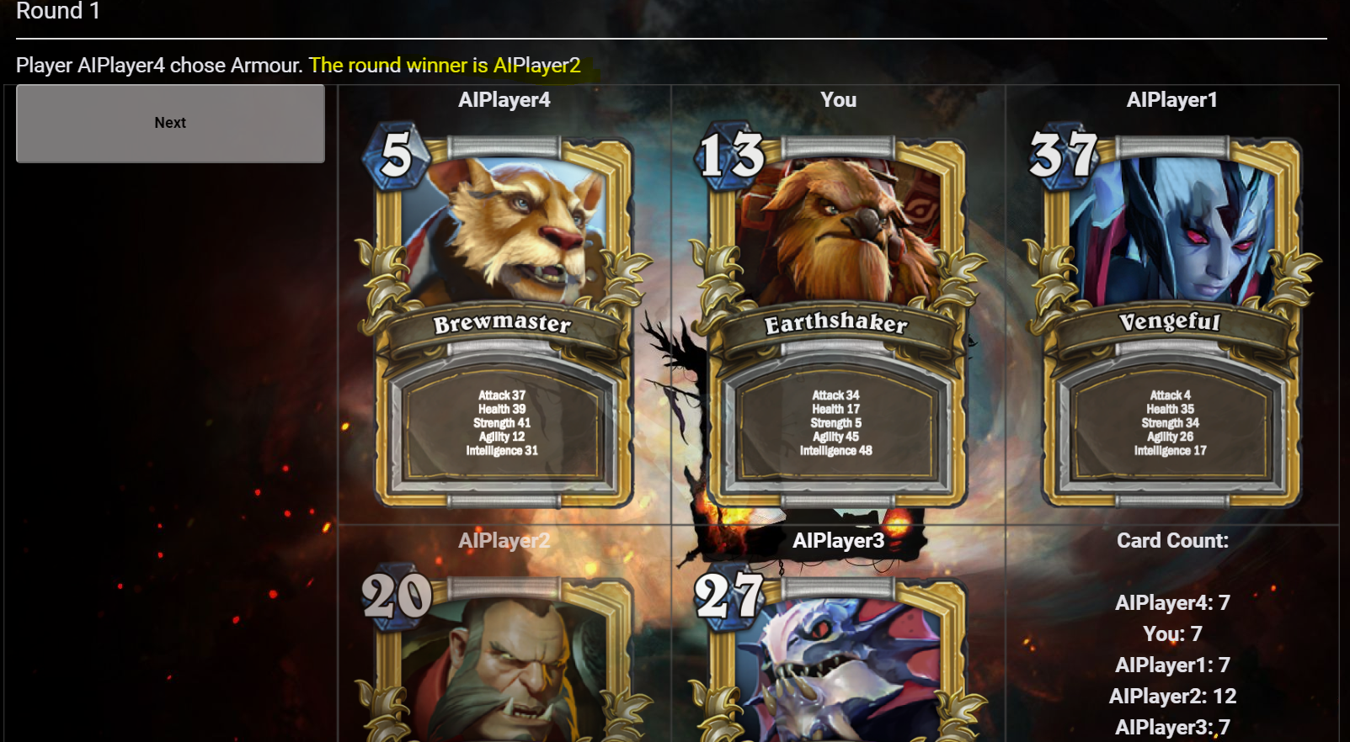

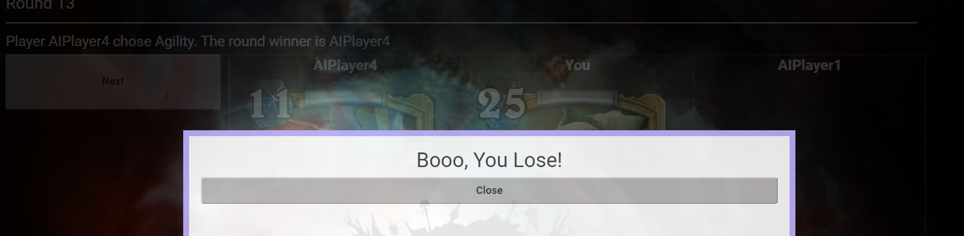

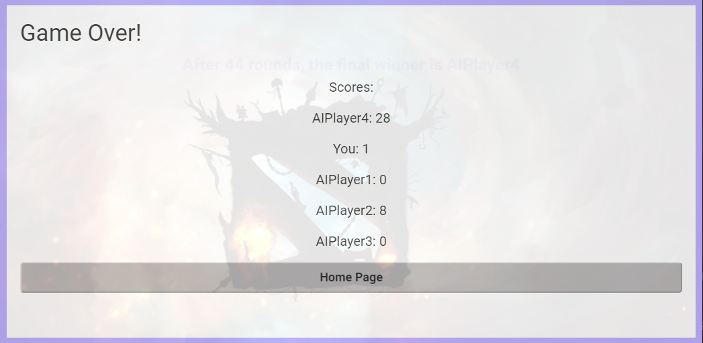

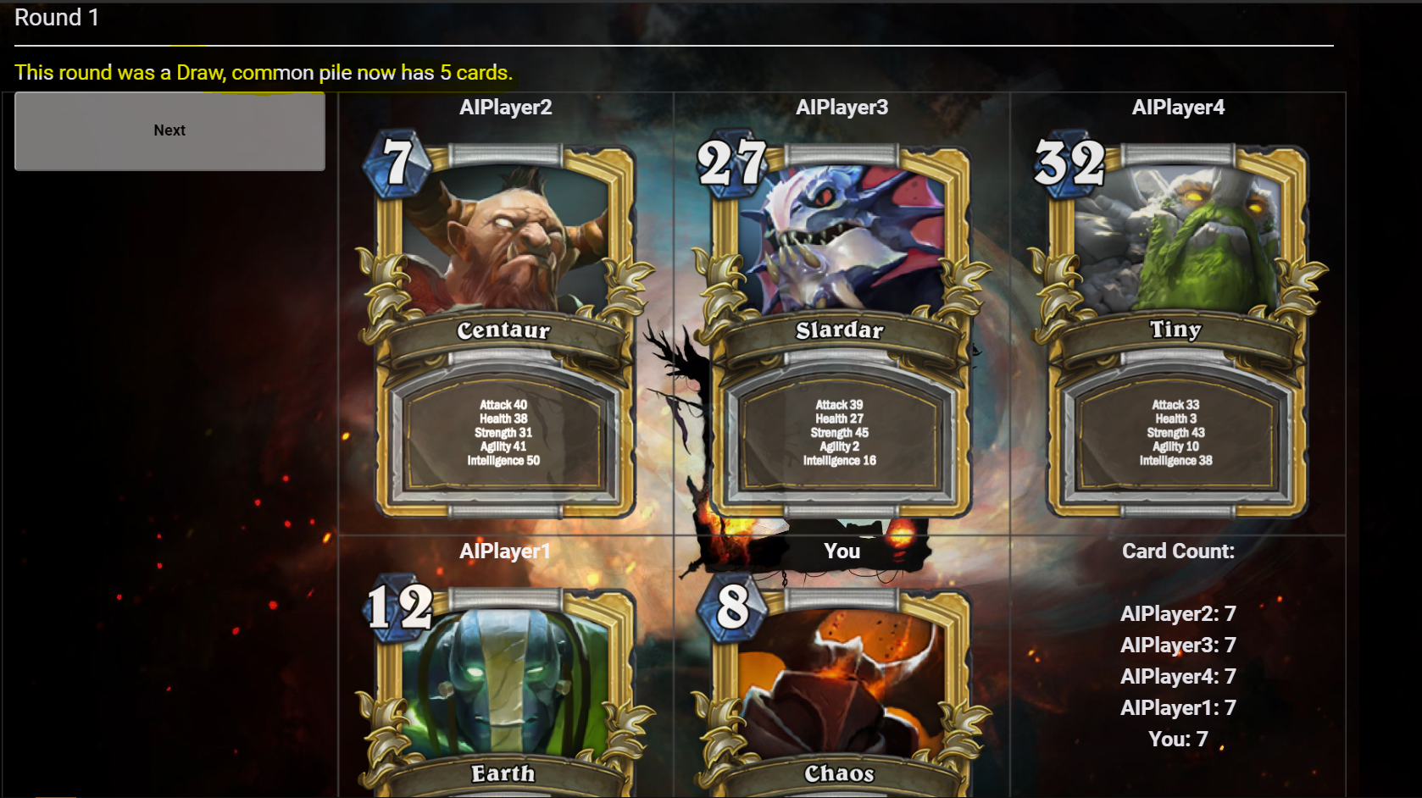

## 1.11 As a human or AI player I want to start the next round if I won the previous one.

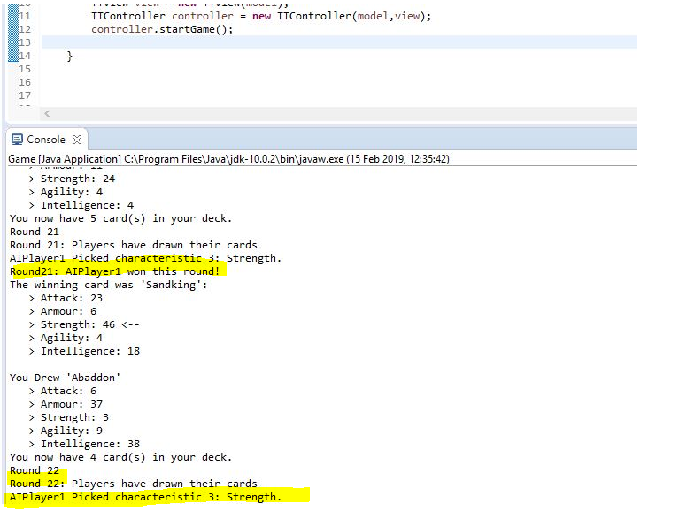

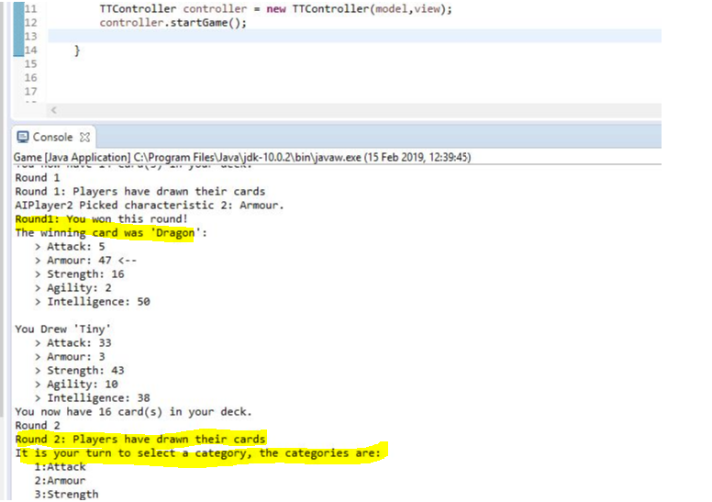

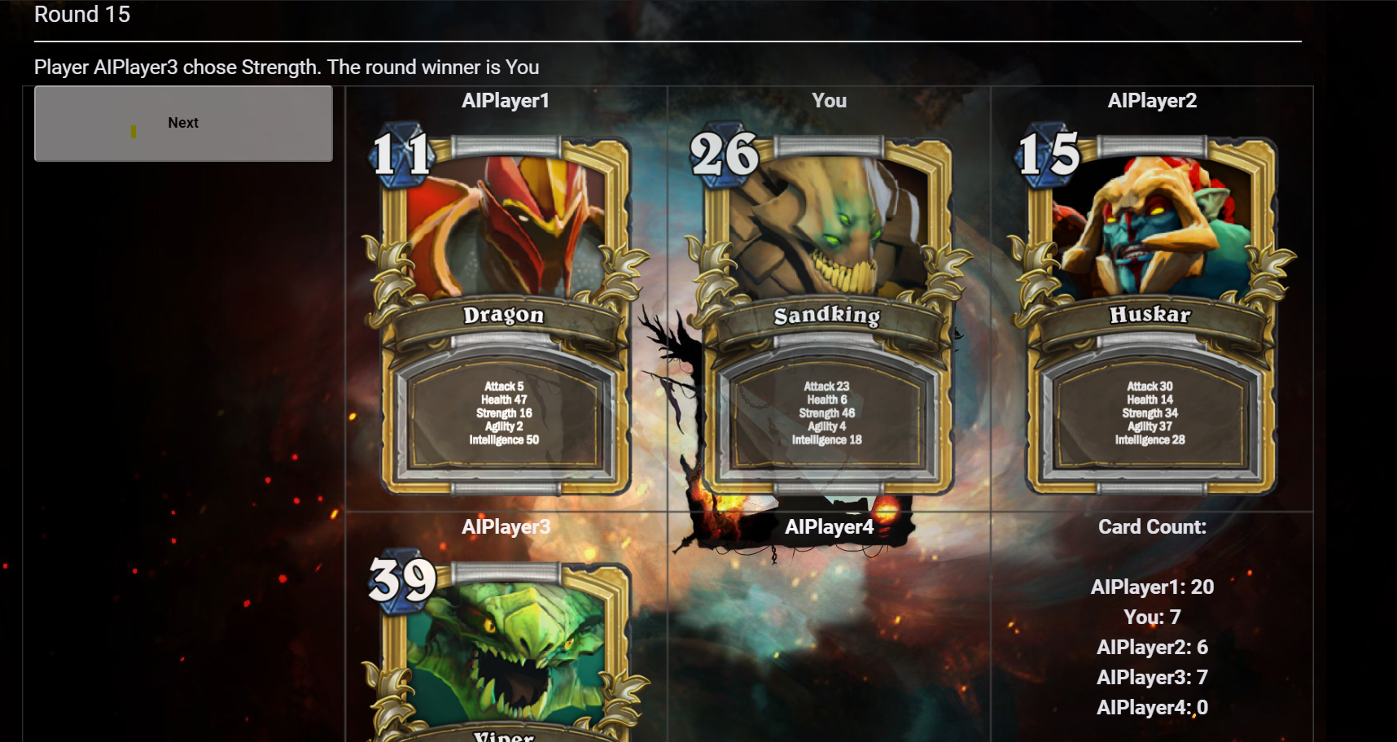

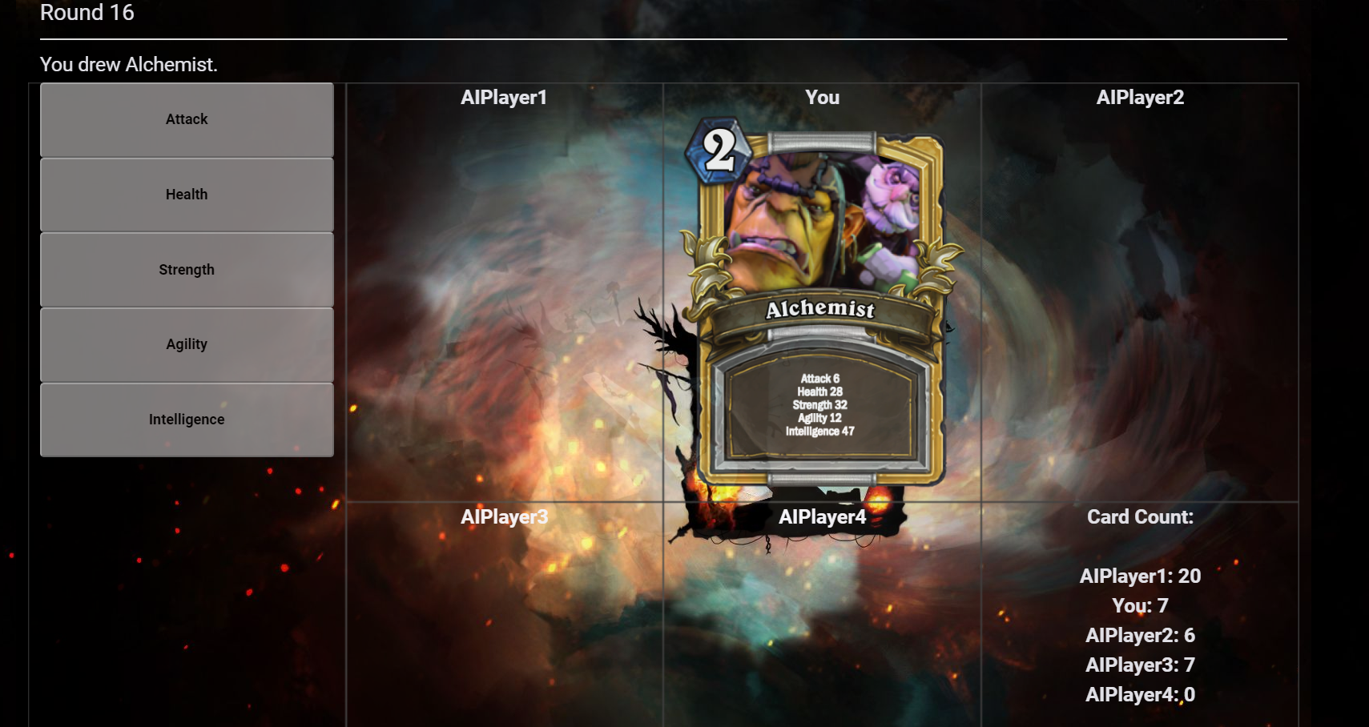

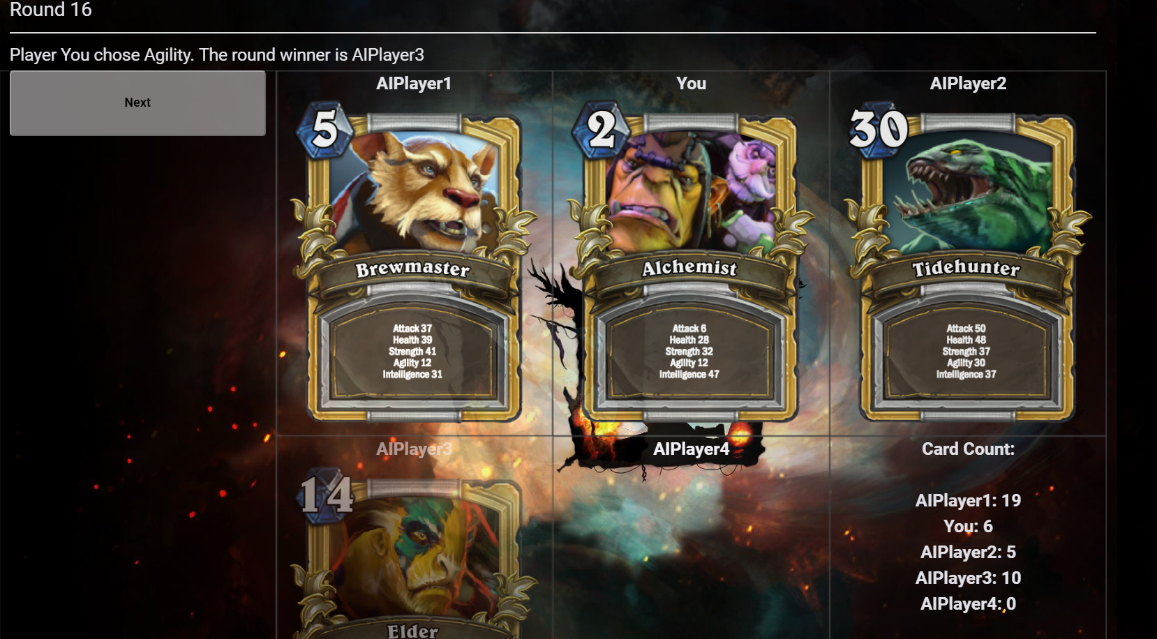

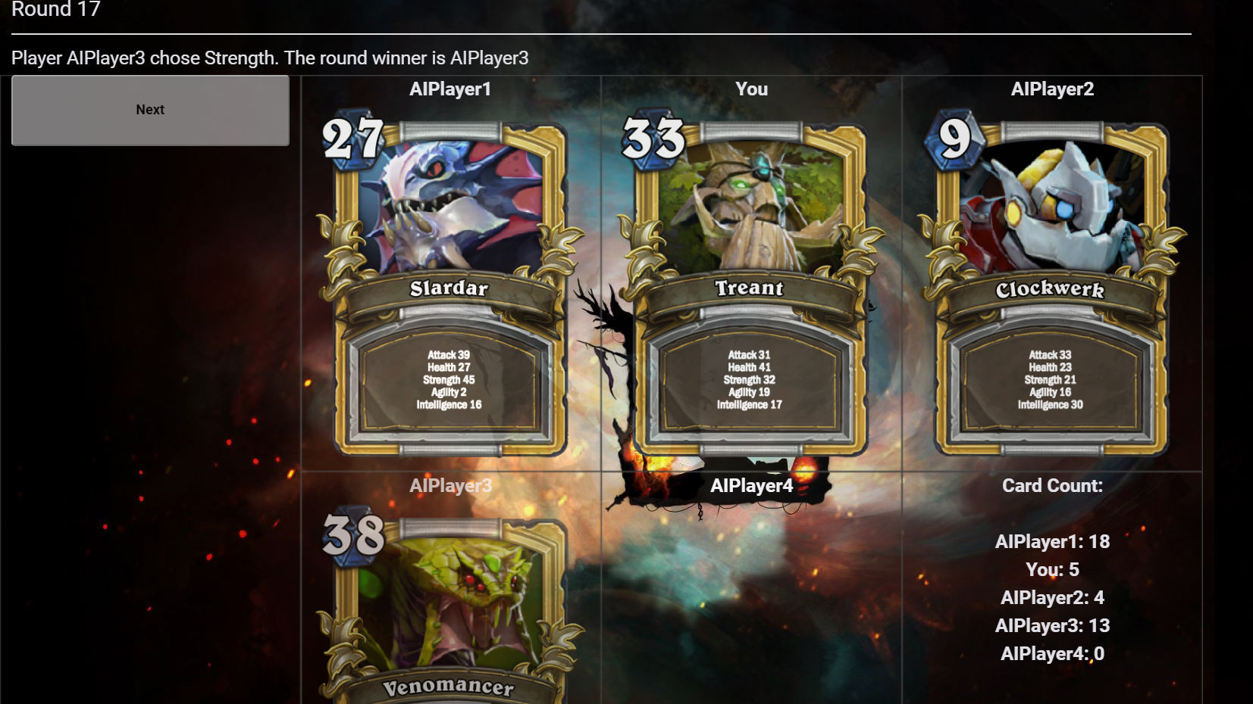

## 1.12 As a dealer I want to make sure that once a player is eliminated, they do not participate in any more rounds.

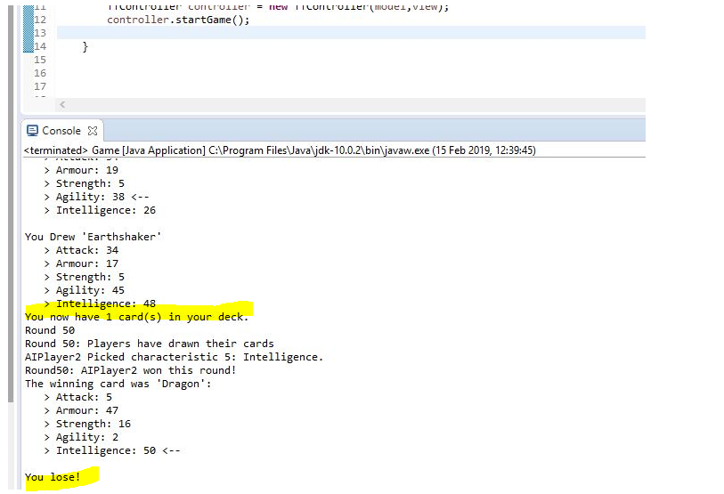

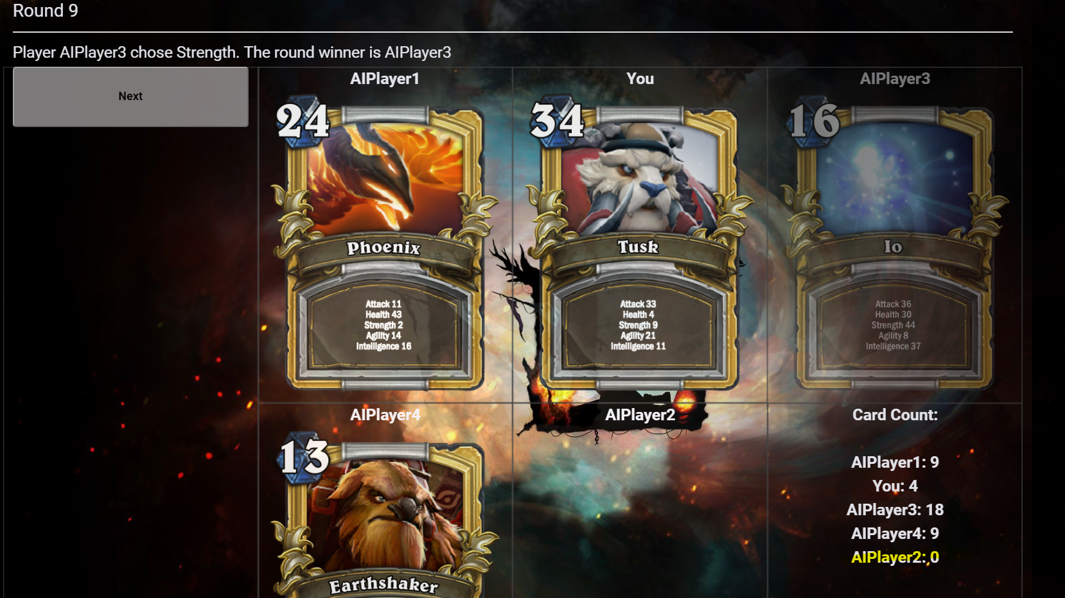

## 1.13 As a human player I want to choose number of AI opponents.

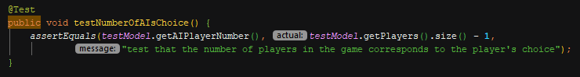





## 1.14 As a user I want to receive an output of gameplay details.

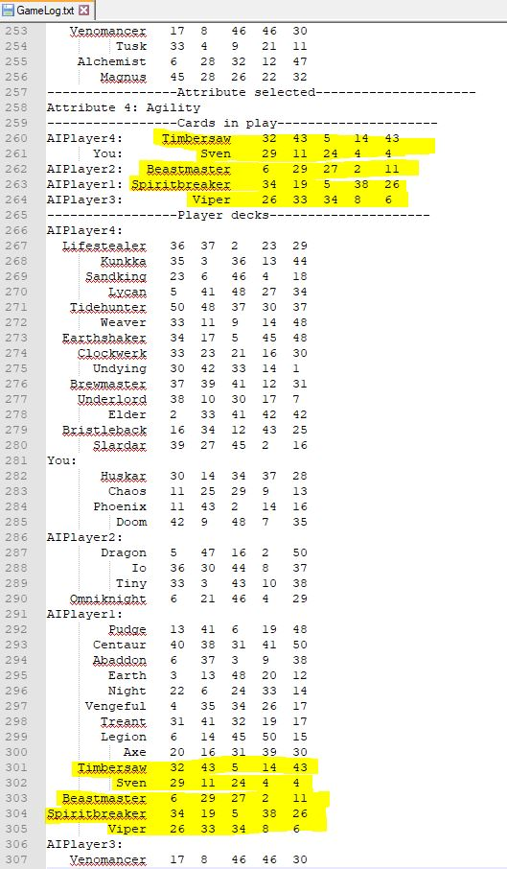

## 1.15 As a user I want to store specific persistent game data at the end of the game.

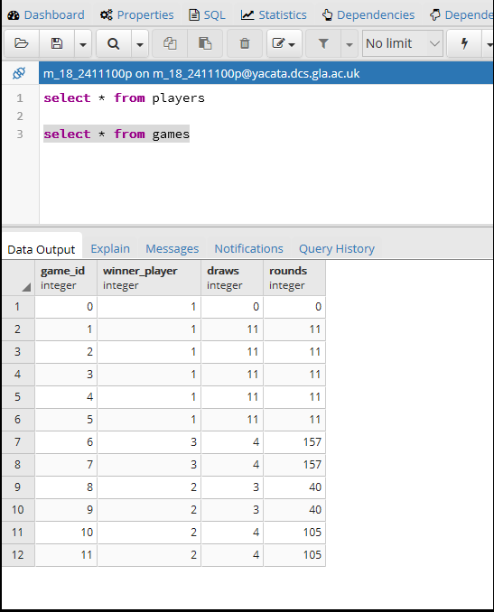

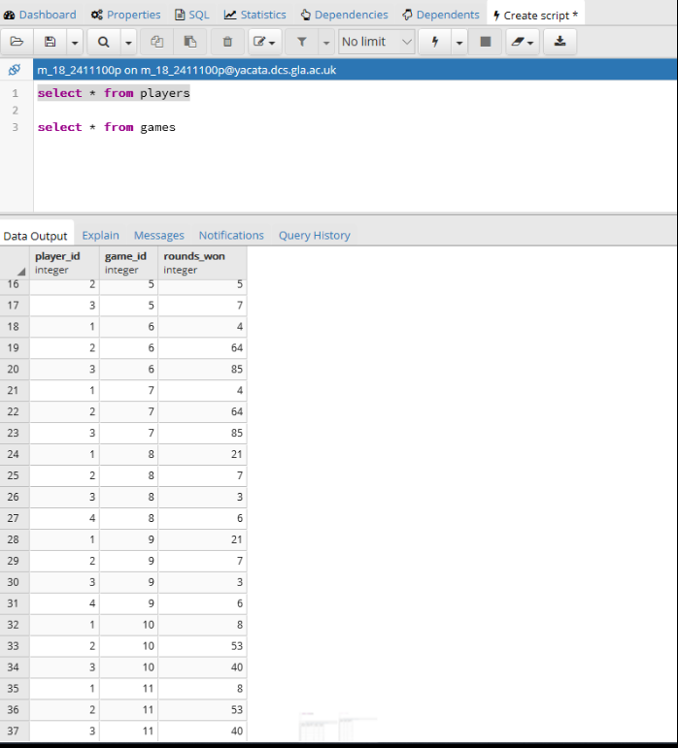

## 1.16 As a user I want to have functional “Start Game” and “Show Statistics” buttons for online mode.

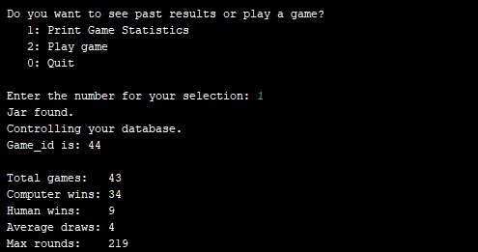





1.17

# Appendix 2 – References

* Initial game screen picture has been retrieved from: https://ro.pinterest.com/pin/761038037000999099/?lp=true - for personal and academic use only.
* All card pictures have been retrieved from: https://dota2.gamepedia.com/Heroes - for personal and academic use only.
* The following web page has been used to generate the cards from the pictures above: http://www.hearthcards.net/ - for personal and academic use only.

1. User story cards are not scanned as these have been brainstormed and amalgamated in Microsoft Excel initially based on the input of all team members. Cards written in *Italics red font* did not make it into the final product version. E_time means estimated time in story points. A_time is actual time in story points.
2. For simplicity, any cmd functionality is a MUST, any database functionality is a SHOULD, any web functionality is a COULD. Everything else is a WOULD LIKE TO HAVE (hereby ‘WLTH’).
3. Time is expressed in story points. **A story point involves one ideal day.** Assumption: smallest unit is 0.1 story points.
4. All JUnit tests can be found in the test directory. The relevant classes are TTModelTest and TTControllerTest. The test methods within these are connected and therefore some functionality may be tested by more than one method.